# PROJECT REPORT

CSE 215 (Programing language-2)

Project Name: Car Rental Management System

Project Member: Rijuan Mahmud (2311483642)

## Contents

* Introduction
* Project Objective
* Hardware Software requirements
* Conclusion

# Introduction

This project is designed so as to be used by Car Rental Company specializing in renting cars to customers. It is a system through which customers can view available cars, register, view profile and book car. The advancement in Information Technology and internet penetration has greatly enhanced various business processes and communication between companies (services provider) and their customers of which car rental industry is not left out. The Car Rental System is being developed for customers so that they can book their vehicles from any location. This application takes information from the customers through filling their details. A customer being registered in the website has the facility to book a vehicle which he requires. It automates manual procedure in an effective and efficient way. This automated system facilitates customer and provides to fill up the details according to their requirements. It includes type of vehicle they are trying to hire and location. The purpose of this system is to develop a web site for the people who can book their vehicles along with requirements from any part of the world.

# Project Objective

* This online car rental solution is fully functional and flexible.
* It is very easy to use.

• This online car rental system helps in back office administration by streamlining and standardizing the procedures.

• It saves a lot of time, money and labour.

• Eco-friendly: The monitoring of the vehicle activity and the overall business becomes easy and includes the least of paper work.

• The portal acts as an office that is open 24/7.

• It increases the efficiency of the management at offering quality services to the customers.

• It provides custom features development and support with the software

Car rental business has emerged with a new goodies compared to the past experience where every activity concerning car rental business is limited to a physical location only. Even though the physical location has not been totally eradicated; the nature of functions and how these functions are achieved has been reshaped by the power of internet. Nowadays, customers can reserve cars online, rent car online, and have the car brought to their door step once the customer is a registered member or go to the office to pick the car. The web based car rental system has offered an advantage to both customers as well as Car Rental Company to efficiently and effectively manage the business and satisfies customers’ need at the click of a button

# Hardware:

The hardware needed does not have to be state of the art in technology. The Project is in Eclipse IDE and does not require special graphic cards that are required to run high Applications. Here is a list of basic Hardware needed to run the program:

• Intel Pentium Processor or any other compatible Processor, 750 MHz or greater.

• Minimum 128 MB of RAM capacity or more.

• Minimum of 16 MB Graphic Card RAM capacities or more.

• Recommended hard disk space of 1 GB or more.

# Software:

Java programming language is being used to develop the project. Program coding will be done with the help of Eclipse/ Netbeans IDE to develop the program coding. Here is a list of basic Software needed to run the program: • Windows 98, 2000,8,10 or XP or Linux operating system.

• Java 2SDK, Standard Edition version 1.4.1 or above.

• Eclipse/ Netbeans IDE editing program.

# Result & Snapshot

Therefore, after implementing all the mentioned libraries as well as software tools, we finally full-fledge software where users can make an account, log in as and also post there own car whenever they want.



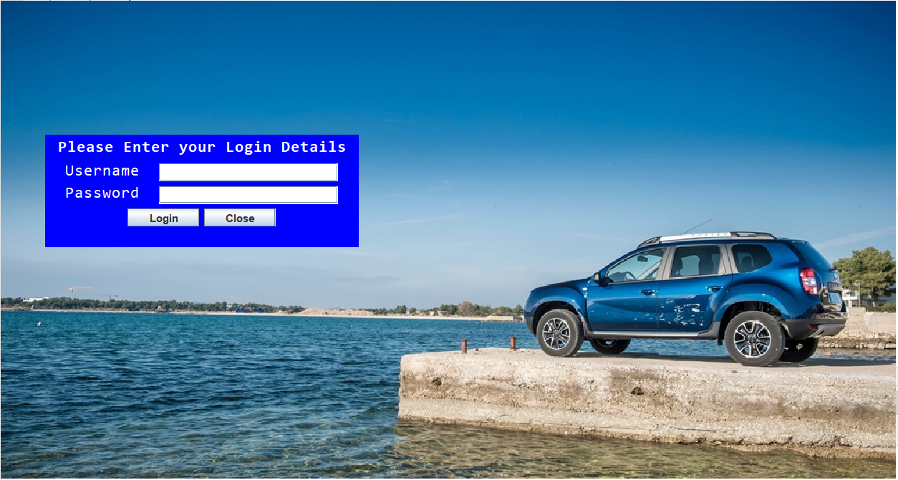

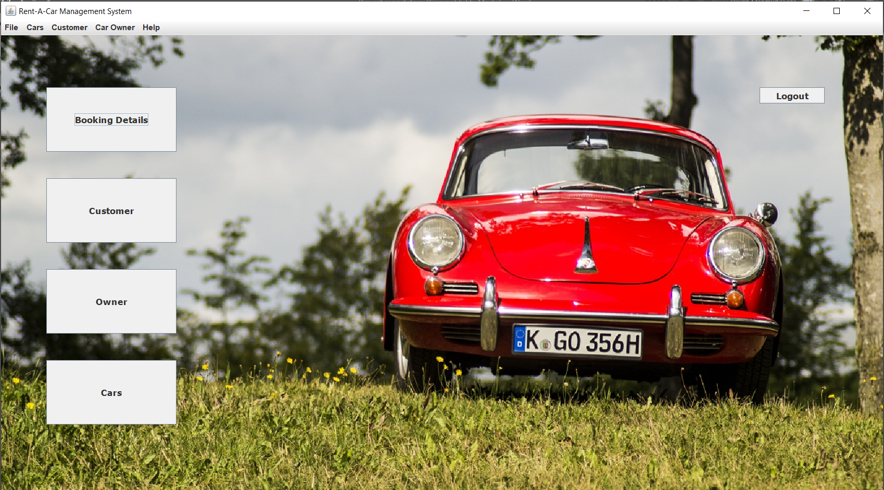

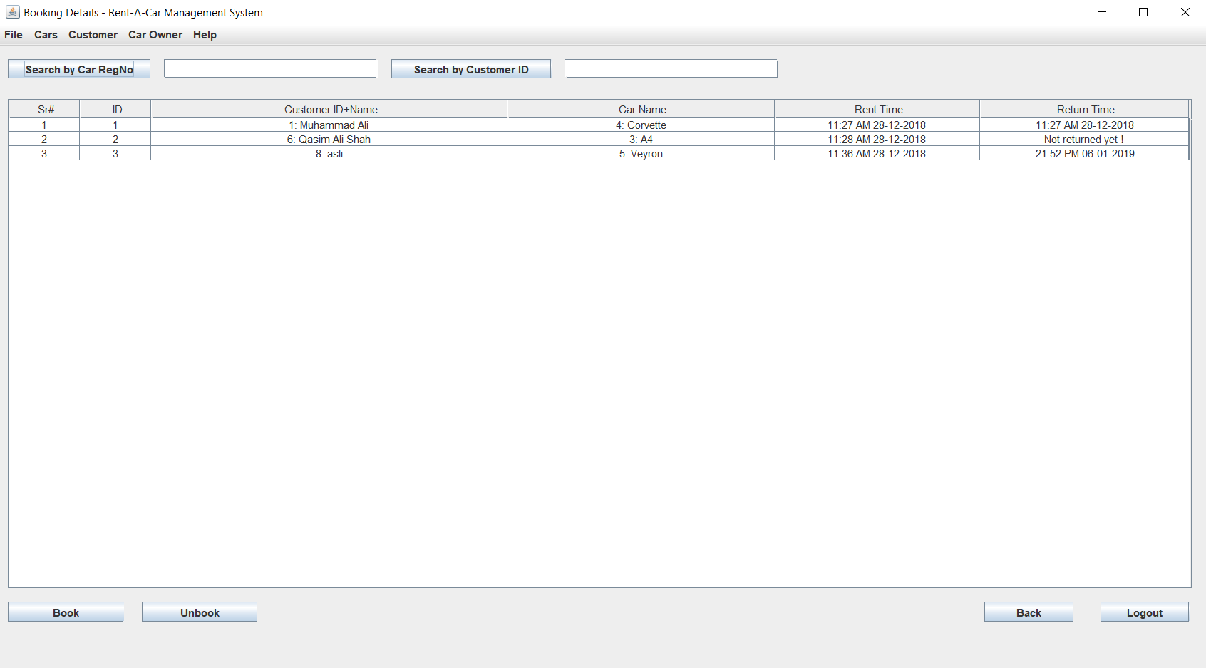

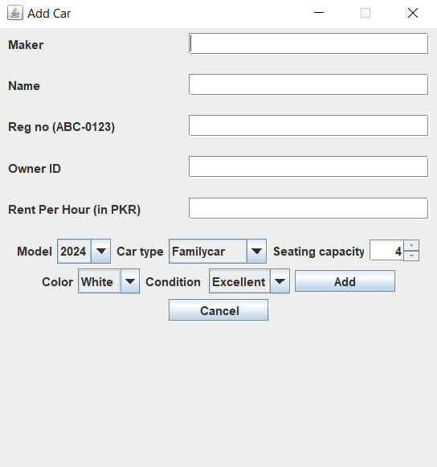

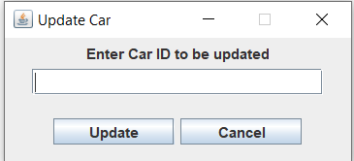

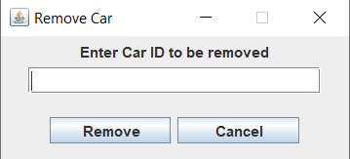

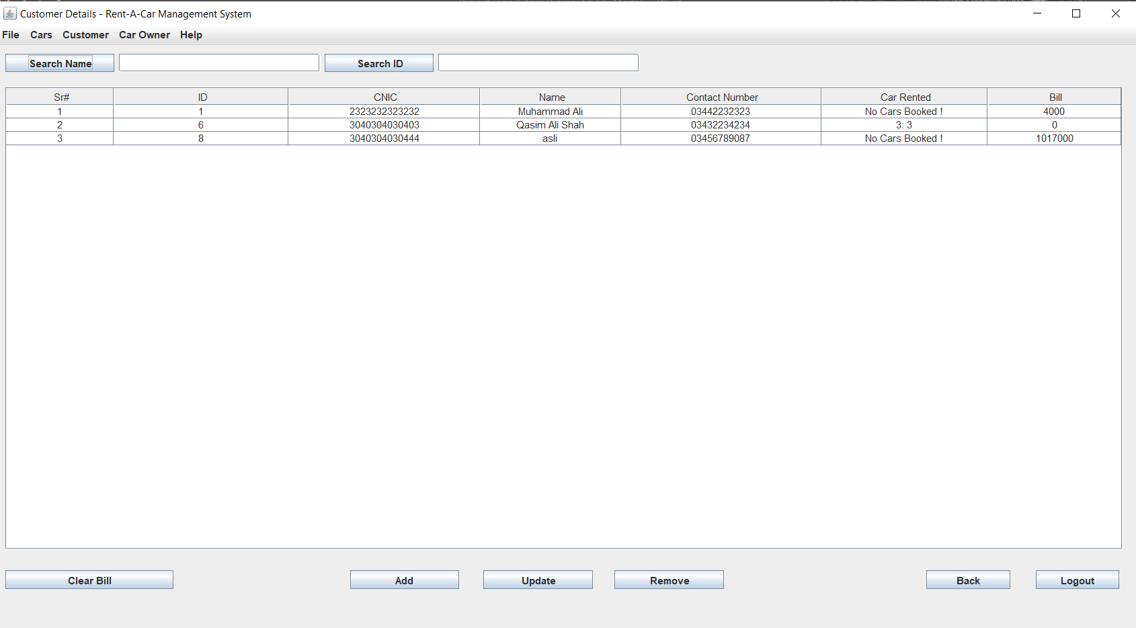

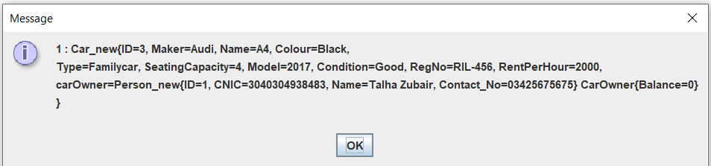

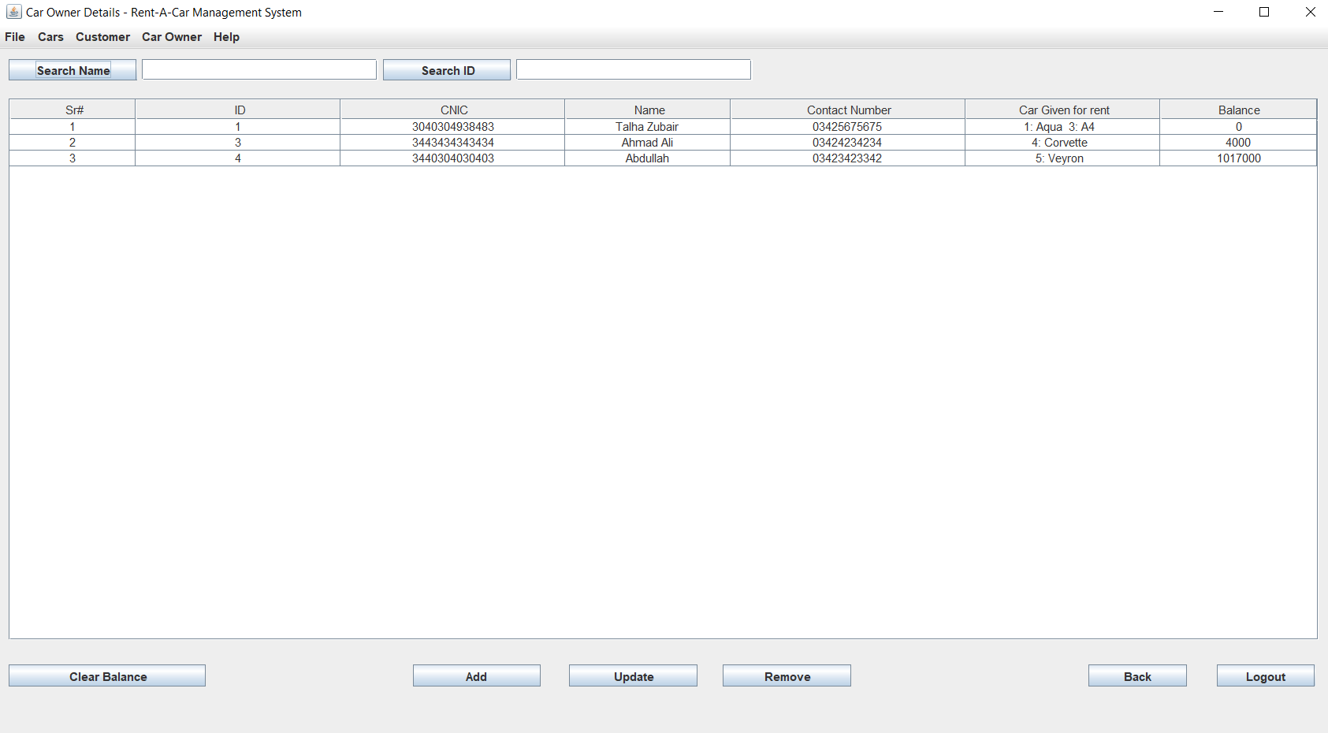

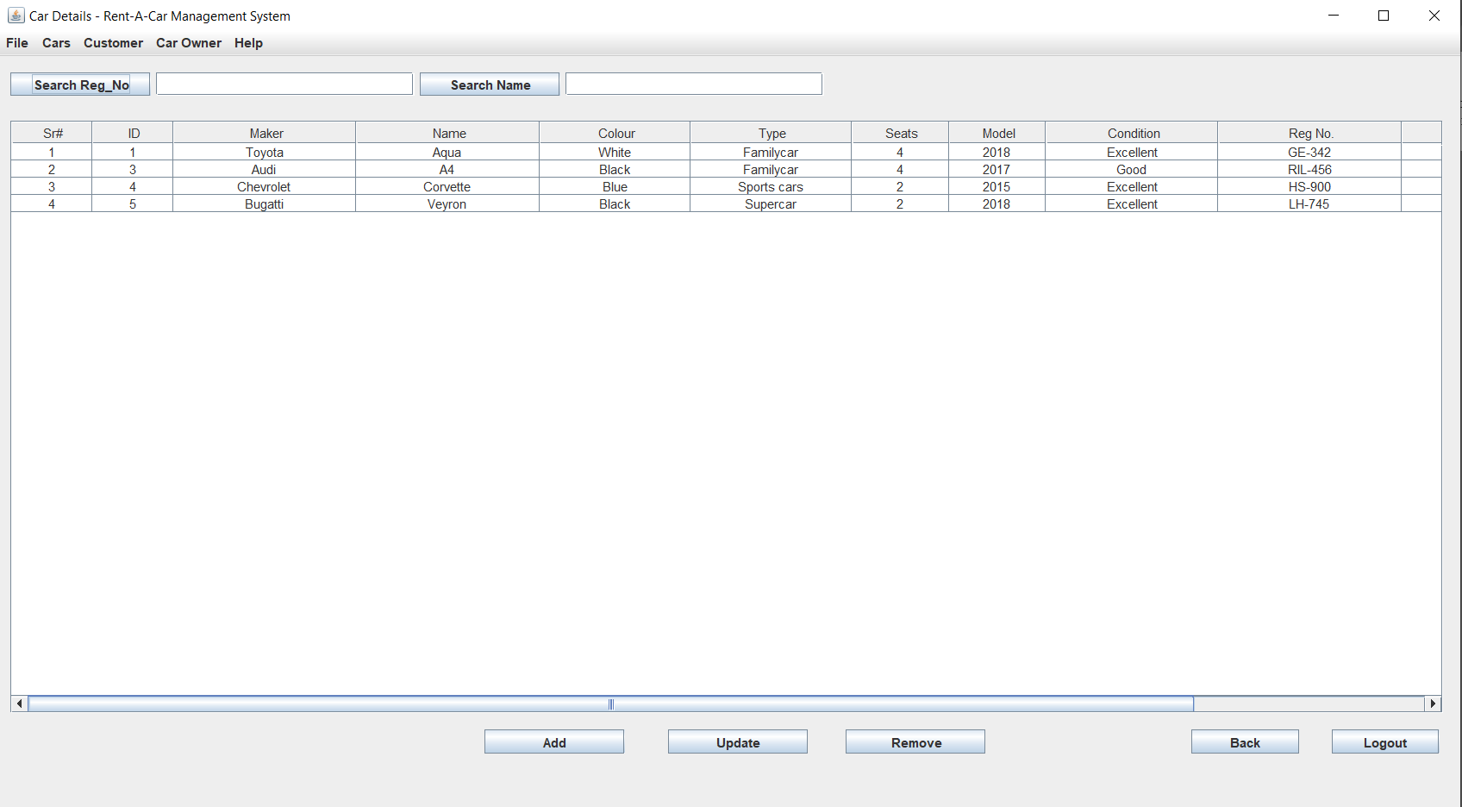

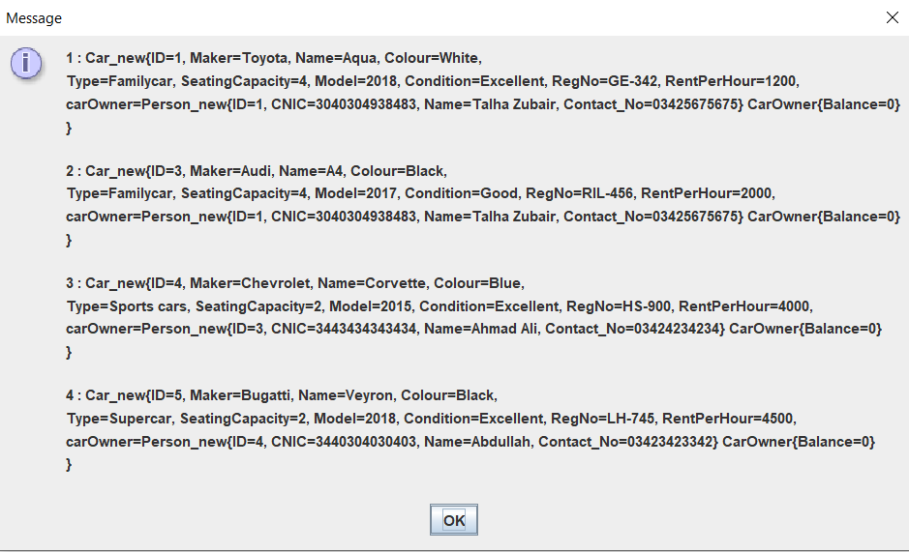

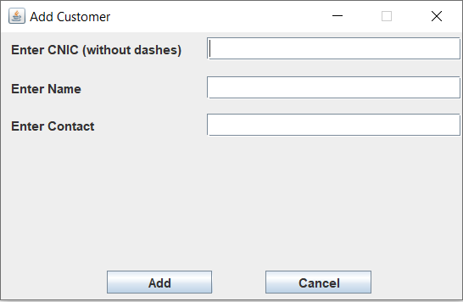

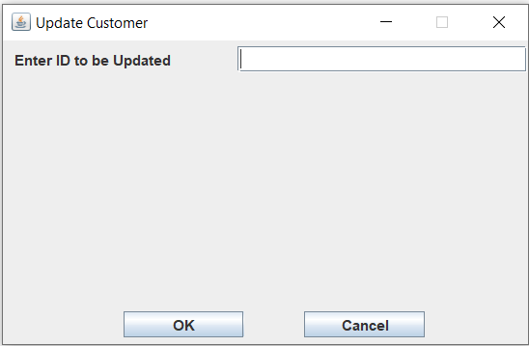

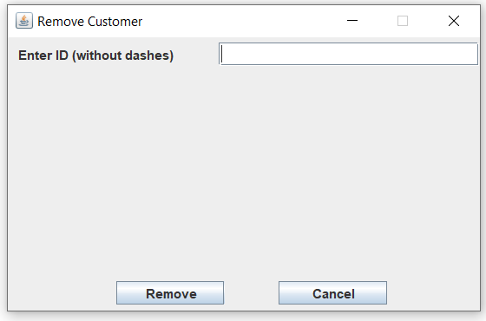

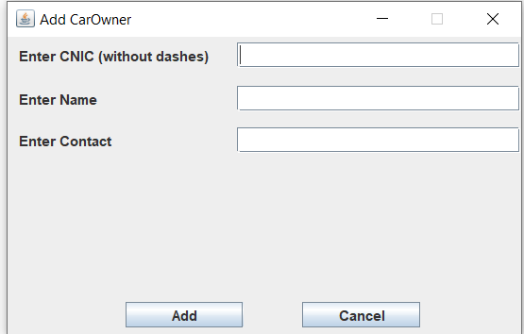

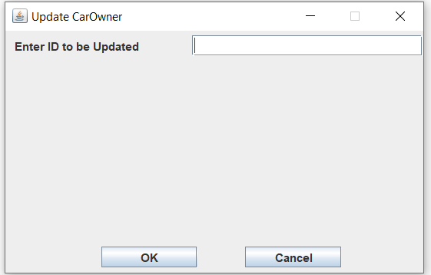

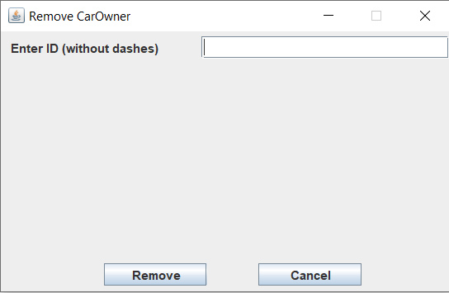

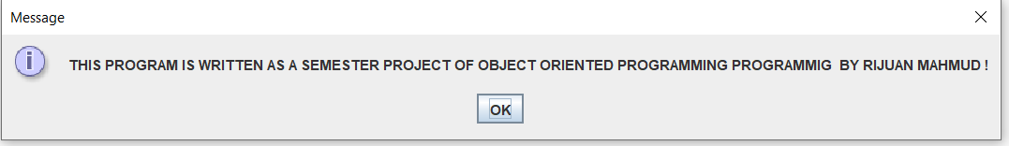

# Conclusion

By developing a project using Java, the project can be run on many platforms. We may need to add or change some of functionalities of the project based around our requirements.